Mechanism Design

**INTRODUCTION:**

Linkages, gears, cams, hinges etc. are important components of [machines](http://en.wikipedia.org/wiki/Machine_%28mechanical%29) and [tools](http://en.wikipedia.org/wiki/Tool). You come across hundreds of examples where linkages have major role to play like [windshield wiper](http://en.wikipedia.org/wiki/Windshield_wiper), [bicycle suspension](http://en.wikipedia.org/wiki/Bicycle_suspension), piston cylinder assembly of an engine and many more. Seeing such a vast range of their application you might now want to try your hand in making some of them and getting them to work.

**Problem Statement:**

Design and fabricate separate mechanisms with manual input that utilizes it to:

* Generate a sine wave, sin(Ѳ)
* An ellipse
* A circle

on a plane sheet of paper

**Rules:**

* No electrical actuators can be used.
* No source of energy can be used other than human power.
* Team distribution
  + Maximum team size : 4 members
  + Only 1 member from Y11 can be in the team.
  + Rest of the members have to be Y12.
* This is a team event, no restriction on number of teams per pool.
* The sine wave has to be clearly drawn over a period of 3π, waveforms should be clearly drawn and not be intersecting .i.e

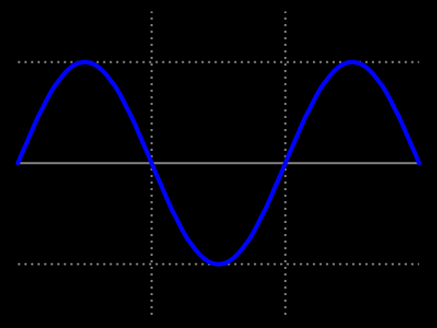

* There should be a distance of at least two mechanical linkages between user input and point tracing out the curve.
* The radius of the circle, the minor axis of the ellipse and minimum amplitude of sine wave is 5 cms.
* Eccentricity of the ellipse, frequency of the wave can be anything.
* Access to 4i, TA201, central workshops is not allowed. Any team found so will be disqualified.

**Judging Criteria:**

**Violation of intent of rules is also a violation and can lead to disqualification**

**Prelims*:***

* Preliminary designs will be submitted from the submitting teams on 25th.
* There is no cap on number of teams for the finals but a design submission is must for moving to the final round.
* The design submissions should contain technical drawings of their proposed mechanism and a write-up on it. A short video explaining it will be helpful but is not a necessity.
* No points will be awarded in this round, but if a team fails to submit its drawings it will be disqualified.
* Changes can be made in these drawings after submission.

**Finals:**

* The distribution of points is:
  + Sine wave: 40
  + Ellipse: 50
  + Circle: 10

For every figure 40% of the total points allotted are for innovation; 40% would take into account the working, fabrication and how you defend your design in front of the judges.

20% of marks distribution as above will be for simulations or calculations of their designs. Simulation can be done in any software.

* A penalty upto a maximum of 40% on the total allotted points can be levied on the basis of accuracy and deviation from decided parameters which will be subjective to the judges.
* Material that can be used for fabrication: wood, mechanical fasteners (screws nuts, bolts, washers, nail etc)
* Judging will be done on the accuracy with which the figure is traced out on paper.
* The judges will question you on your designs and the design philosophy behind them. The combined score will be tallied for a team.
* Teams can use a single pair of gears (2) but a penalty of -5 points will be levied for each extra gear used other than the above mentioned pair.
* Innovative mechanisms will be fetching extra points.
* In case of multiple pool entries, their designs should not be same; this will lead to disqualification of one of the teams.
* The decision of judge will be binding and irrefutable.





